- Data Types as Classes
- In .NET, each data type is associated with a class, which offers few methods for the variable (object).
- All of the data type classes are the sub classes of an ultimate base class called “Object”.
- All the data type classes are the members of “System” namespace.
- You can see the data types along with the respective class names in the following table.
Data Type | Class Name
sbyte | System.SByte
byte | System.Byte
short | System.Int16
ushort | System.UInt16
int | System.Int32
uint | System.UInt32
long | System.Int64
ulong | System.UInt64
float | System.Single
double | System.Double
bool | System.Boolean
char | System.Char
decimal | System.Decimal
string | System.String

- The “Object” class, which is a base class for all other data type classes, offers few methods, which can be accessible by the instances of data type classes (variables).
- You can observe the methods offered by “Object” class in the following table.
Method | Description
Equals(value) | Checks the equality of the value of the object with the given argument value. If both are equal, then returns “true”, otherwise returns “false”.  Ex:  MyObj.Equals(AnotherObject);  In this example, “MyObj” will be compared with “AnotherObject”.
GetType() | Gets the name of the class, for which, it is declared.  Ex:  MyObj.GetType();
ToString() | Converts the value of the object and returns it.  Ex:  MyObj.ToString();  In this example, the value of “MyObj” will be converted as string type, and that string value will be returned.

Application 7: Demo on “Object” class methods

using System;
using System.Collections.Generic;
using System.Linq;
using System.Text;

namespace ObjectClassMethods
{
class Program
{
static void Main(string[] args)
{
int x = 100;
int y = 100;
Console.WriteLine("x is " + x);
Console.WriteLine("y is " + y);
if (x.Equals(y))
Console.WriteLine("x is equal to y");
else
Console.WriteLine("x is not equal to y");
Console.WriteLine("x is the type of " + x.GetType());
string s = x.ToString();
Console.WriteLine("s is " + s);
Console.Read();
}
}
}

Output:
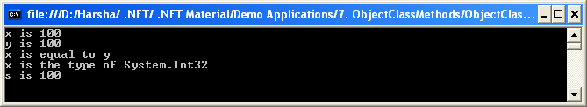

- Constants
- Constants look just like variables, but concept wise, they differ from variables.
- The main differences between constants and variables are:
  - The value of constants can’t be changed during the program execution time.
  - The constants should be initialized at the time of its declaration.
- To declare constants,
Syn: const datatype constantname=value;
Ex: const int x=100;
Application 8: Demo on Constants
using System;
using System.Collections.Generic;
using System.Linq;
using System.Text;

namespace Constants
{
//An application, that calculates area of circle
class Program
{
static void Main(string[] args)
{
const double PI = 3.14;
Console.WriteLine("Enter r value:");
int r = Convert.ToInt32(Console.ReadLine());
double area = PI * r * r;
Console.WriteLine("Are of circle is " + area);
Console.Read();
}
}
}

Output:
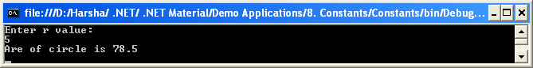

- Variable Scopes
- A “variable scope” simply is something, which decides the lifetime of the variable.
- The variable scope depends on the place, where the variable is declared in the program.
- For example, a variable is declared in “if” block, is available only within the “if” block itself.
- To have a better idea on this, we discuss about all available scopes in C#.

Scope | Description | Accessibility | Example
1) Class level scope | A variable declared within the class. | This is known as data member, which accessibility is based on the access modifier you use. (like private, public etc.) | class sample  {  private int x;  }
2) Method level scope | A variable declared within the method | Accessible only within the method only. | void sample()  {  int x;  //some code  }
3) Block level scope | A variable declared within a block. Ex: if block, else block, for block, try block, catch block etc.  Note: A block can be specified when you use curly braces. { } | Accessible only within the block only. | if (x==y)  {  int x;  //some code  }

- Strong Rule to follow: Multiple variables with same name within the same scope can’t be declared anywhere.

- Operators
C# supports different kinds of operators.

- Assignment operator
=
- Arithmetical / Mathematical operators
+, -, *, /, %
- Self Assignment operators
+=, -=, *=, /=
- Prefix and Postfix operators
++, --
- Relational operators
==, !=, <, >, <=, >=
- Logical operators
&&, ||, !
- Comment operators
//xxxxxxxxxxxxxx
(or)
/* xxxxxxxxxxx
xxxxxxxxxxx
xxxxxxxxxxx*/

- Concatenation Operators
+
- Block specification operators
{ }
- Method specification operators
( )
- Conditional operator
? :
- Dynamic memory allocation operator
new
Operator Precedence:
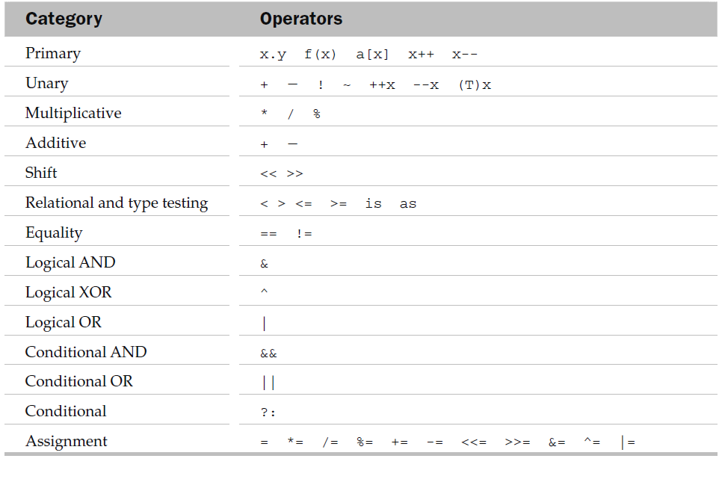
- Flow Control with Control Statements
- C# supports several types control statements.
- These are almost all similar to C++.

Types of Control Statements
- Branching Control Statements
  - if
  - switch-case
  - break
  - continue
  - goto
- Looping Control Statements
  - while
  - do-while
  - for

Note: All the syntaxes are same as C/C++. Just for idea, we recollect the syntaxes now.

Implementation Syntax of Control Statements
- Branching Control Statements
  - if
    - Simple if
if (condition)
{
----;
----;
}

    - if-else
if (condition)
{
----;
----;
}
else
{
----;
----;
}

    - else-if
if (condition)
{
----;
----;
}
else if (condition)
{
----;
----;
}
else if (condition)
{
----;
----;
}
else
{
----;
----;
}

    - Nested-if
if (condition)
{
if (condition)
{
----;
----;
}
else
{
----;
----;
}
}
else
{
if (condition)
{
----;
----;
}
else
{
----;
----;
}
}

  - switch-case
switch (variable)
{
case value1: ---------; break;
case value2: ---------; break;
case value3: ---------; break;
case value4: ---------; break;
default: ---------; break;
}

  - break
for loop / while loop / do-while loop
{
----------;
----------;
break;
----------;
}

  - continue
for loop / while loop / do-while loop
{
----------;
----------;
continue;
----------;
}

  - goto
----------;
----------;
----------;
goto labelname;
----------;
----------;
labelname:
----------;
----------;
----------;

- Looping Control Statements
  - while
initialization;
while (condition)
{
----------;
----------;
----------;
Increment / decrement;
}

  - do-while
initialization;
do
{
----------;
----------;
----------;
Increment / decrement;
} while(condition);

  - for
for (initialization; condition; increment/decrement)
{
----------;
----------;
----------;
}

Note: You can also implement nested loops as you implemented in C/C++.

